NAME: NOMBUSO HALALISIWE ZAKWE

GEOGRAPHY TASK 2

MARKS: 100

**GEOGRAPY ASSIGNMENT**

The city is most known for being the home of the busiest port in south Africa .It is also a major hub for Manufacturing as well as a tourist hotspot because of its sunny climate beautiful beaches, Unique culture ,and various attraction . The city’s population is just over 595, 00 .The current population of South Africa is 59,444,897 as of Monday, SEPTEMBER 7 2020 based on Word meter elaboration of the latest united national data. South Africa is the fifth African country with the largest population, counting approximately 60 million individual in 2020 the largest city of south Africa was cape Town, The capital of Western cape counted 3.4 million inhabitant whereas South Africa second largest city was Durban (eThekwini municipality) WITH 3.1 Million inhabitant note that where observing the number of inhabitant by Municipality, Johannesburg is counted as largest city Municipality of south Africa.

According to Durban history Durban formerly port natal, largest city of KWAZULU-NATAL province and chief seaport of south Africa located on natal bay of the Indian ocean . European settlement began with a band of cope colony traders led by trances G farewell who charted the port in 1824 and named the site port Natal .LAND was ceded to the group by shake , the Zulu king whose right to take that action is disputed and the old fort now a museum was built . Durban was founded in 1835 on the site of port natal and was named for sir Benjamin Durban

Sprawling along the coast, Durban is overloaded to the South by the bluff hills separating the land locked by sea and stretches across the uMngeni river to the height of Durban north its civic and business Centre is on flat land, rising gently to the slopes of the white residential district of the Berea, a ridge of hills encircling the harbor and beach, Durban numerous parks include the botanic garden with its rose gardens, and snake park with its collection of poisonous reptiles. The city is home to the University of KWAZULU-NATAL, formed in 2004 through the merger of the University of Durban Westville originally for Indian students Cultural and sporting events are held in MOSES MABHIDA Stadium part of the larger king park sporting precinct a commercial, retail and leisure district. Development of Durban Harbor one of words major commercial parts, began in 1 855 serving the Witwatsrand industrial region it’s a major container port and point of entry for bulk raw materials, capital goods, and industrial equipment minerals, coals, sugar, and grain are exported and oil is refined after word war1 Durban changed from a prim Victorian town to a modern metropolis with sky scrapers and multistoried building it’s the headquarters of south Africa’s Sugar industry

Durban ( with adjacent PINETOWN ) HAS a large Indian population than white, the largest concentration of Indian in South Africa. Ntuzuma, UMlazi, and Embumbulu district to the immediate west were developed as black, commuter suburbs, many blacks moved from Durban to these areas in the late 1970s under apartheid policies. Durban is administered by the EThekwini Municipality. Pop (2001) city 536,644; Municipality 3, 090, 27

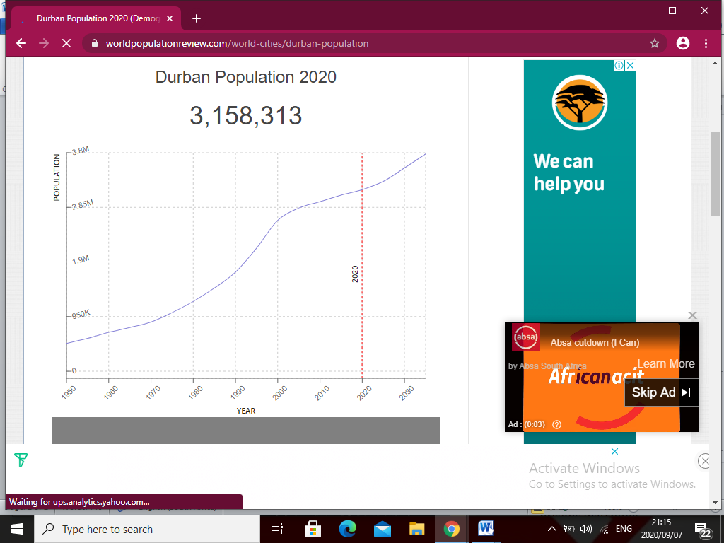

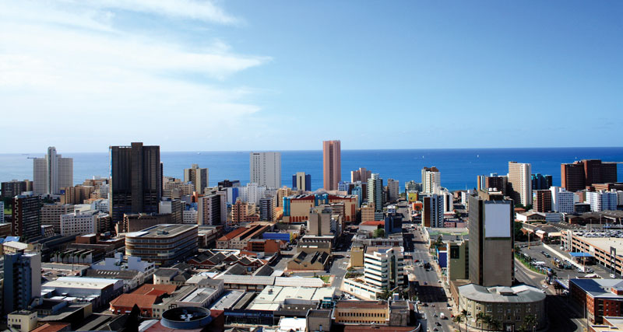

**POLLUTION IN DURBAN**

Air pollution, drinking water pollution and inaccessibility, dissatisfaction with garbage disposal, dirty untidy, noise and light pollution, water pollution. Durban-The Durban harbor has borne the brunt of litter from storm water drains following heavy rainfall operational however, the ingress of waste impacted on vessel movements and as of midday on Wednesday three vessels were unable to berth or sail into the Maydon Wharf precinct.

Transnet national port Authority has commenced on a major clean-up to remove the large volume of water. Durban south basin has named as one of the hotspot for high air pollution levels in South Africa. TYPES OF AIR POLLUTANTS in order to understand the causes of air pollution several division can be made

Air pollution can be classified into two sections –invisible and visible air pollution

VISSILE AIR POLLUTION-as the name suggest, can be visible. The smog you see over a city is an example of visible pollution

INVISIBLE AIR POLLUTION-Are less noticeable, but they can be more deadly. Good example of invisible air pollutants are sulfur dioxide carbon monoxide and nitrogen oxide it can be further divided into primary and secondary air pollutants if we deep

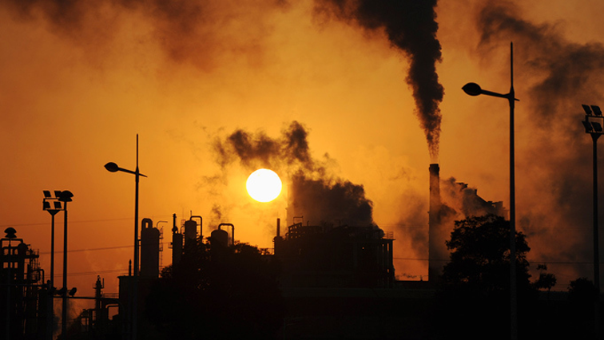

**Population Growth**

The city in the past several decades has seen significant growth, although it has slowed to just over 1% in recent years. A population boom in the late 1990s and early 2000s led to the development of shanty towns. Today, many of these have been demolished as the government has developed low-income housing. Growth is expected to continue for Durban, although [crime rates](https://en.wikipedia.org/wiki/Durban#Crime) have recently begun to rise again after declining in the 2000s. Whether the increase in crime will continue and whether or not it will affect future population growth remains unseen.

**Pollution growth**

To prevent pollution from these sources, the MPCA provides education, guidance, and incentives for reducing air pollution. We have programs for businesses, cities, non-profits, and communities that address a range of environmental problems, including air quality.

Drive your car less. Vehicle exhaust is a major source of air pollution in Minnesota. Carpool. Bike. Bus. Telecommute. Electric vehicles. How could you burn less fuel?

Keep your car in good repair. Fix exhaust and oxygen sensor problems ASAP. [Check tire pressure](https://www.pca.state.mn.us/living-green/check-your-tire-pressure-reduce-pollution) monthly.

Turn off your engine. An [idling engine](https://www.pca.state.mn.us/featured/no-idling-please-young-lungs-work) creates a hot spot of pollution. Buses and big trucks produce particularly unhealthy exhaust. Parents and teachers can help their schools and day-cares develop and implement no-idling policies. [MPCA has resources to get started](https://www.pca.state.mn.us/featured/no-idling-please-young-lungs-work).

Don't burn your garbage. Burning your household garbage is dangerous to your health and our environment, and generally against the law in Minnesota. If you're still using a burn barrel, wood stove, or fire-pit for your trash, it's time for a change. [Learn what you can do.](https://www.pca.state.mn.us/dont-burn-your-garbage)

Stop having campfires in the city. Smoky areas resulting from campfires in the city can cause unhealthy conditions for hundreds of people, especially during stagnant weather conditions. Since cities have elevated levels of pollution compared to Greater Minnesota already, please limit the number of campfires you start in urban locations. If you do have a campfire:

* + Keep campfires brief and small--3 feet across or less.
  + Burn only dry fire wood. In the Twin Cities it is illegal to burn any waste in a fire, even yard waste.
  + Never start campfires during an [air quality alert](https://www.pca.state.mn.us/air/current-air-quality). You can receive texts or emails when air pollution alerts are in effect.

Plant and care for trees. Trees filter pollutants and absorb carbon dioxide. Trees also release oxygen into the atmosphere and help cool our homes. Learn more about the [benefits of trees](https://www.pca.state.mn.us/living-green/benefits-trees).

Switch to electric or hand-powered lawn equipment. Gas-powered engines like those on lawnmowers and leaf or snow blowers often lack pollution control devices. An hour running a lawn mower can produce nearly the same amount of pollution as a 100-mile car trip! Use hand-powered or electric lawn care equipment instead.

[Use less energy](https://www.pca.state.mn.us/saving-energy). Choose efficient appliances and heating systems. Get an energy audit and follow the advice. Turn off electrical stuff you are not using. It all adds up.

